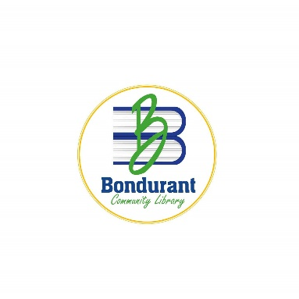
Agenda
Bondurant Community Library - Library Board of Trustees
104 2nd Street NE
Bondurant, Iowa 50035
Bondurant Community Library – Group Study B
5 pm
Monday, March 16, 2026
A virtual meeting is being offered. Participants wishing to speak on a topic should message the meeting moderator. All participants are asked to mute their individual computers at times when they are not speaking to minimize background noise.
To connect to the virtual meeting please use the following link
https://us02web.zoom.us/j/82735331748?pwd=z8p9EhMF1gFMW9tZzJvqDBFBCaTBQQ.1
To phone into the meeting please call the following number: 1 312 626 6799 US (Chicago)
Meeting ID: 827 3533 1748 Password: 827 3533 1748

Roll Call
Call to order
- Guests Present
- Perfecting and Approving the Agenda
  - Discussion regarding Middle School Book Club
- Board President Items
- Adjournment
Next meeting April 1, 2026

Any person with a disability who requires a modification or accommodation in order to participate in the meeting, or any person with limited English proficiency (LEP) who requires language assistance to communicate with the Library Board of Trustees during the meeting, should contact the Library Director, (515) 967-4790 or michellk@bondurantlib.com, no fewer than two business days prior to the meeting to enable the Bondurant Community Library to make reasonable arrangements to assure accessibility or language assistance for the meeting.

